Newly promoted, Detective Sergeant William Warwick has been reassigned to the drugs squad. His first case: to investigate a notorious south London drug lord known as the Viper.  
  
But as William and his team close the net around a criminal network unlike any they have ever encountered, he is also faced with an old enemy, Miles Faulkner. It will take all of William’s cunning to devise a means to bring both men to justice; a trap neither will expect, one that is hidden in plain sight . . .  
  
**Filled with Jeffrey Archer’s trademark twists and turns, *Hidden in Plain Sight* is the gripping next instalment in the life of William Warwick. It follows on from *Nothing Ventured*, but can be read as a standalone story.**

**2.**



The search for meaning and the importance of our life is one constant thought that always crosses everyone’s mind. It is not meaning that the individual searches for in their life, but at the ground level, what the person is seeking is hope, life-lessons, the truth and a dash of motivation every now and then. All this search makes one feel a sense of fulfilment in their life. Learning is a part of life and man’s quest for life-lessons will never cease until death. Presenting you a collection of short stories, which is an attempt to make you see life and its subtle messages through a different lens.

3.



यह पुस्तक पंजाबी के प्रसिद्ध संत-कवि बुल्लेशाह के व्यक्तित्व और कृतित्व पर आधारित है। पंजाब की माटी की सौंधी गंध में गूँजता हुआ नाम है बुल्लेशाह, जिन्हें उत्तर भारत के एक अति सम्मानित सूफी कवि का रुतबा हासिल है। उन्होंने हमेशा जाति व्यवस्था को नकारा, पाखंड का विरोध किया, दीवानगी से भरे इश्क़ के कायल रहे, वह भी रब के साथ। उनकी बानी में पंजाब की लोक-संस्कृति कूट-कूटकर भरी थी। बुल्लेशाह वास्तव में जीवन और मानव मात्र के कल्यान के गायक कवि थे।उनकी एक-एक रचना में जीवन और जगत का सत्य झलकता है। इस पुस्तक में उनकी प्रतिनिधि कविताएं पंजाबी और उर्दू में हिंदी व्याख्या के साथ दी गई है|

4.



On a train journey to Varanasi, Yogi meets John, a writer and narrates him a gripping story about three friends: Krish, an IITian pursuing his entrepreneur dream; Tony, a vodka craze-high school-dropout; and Asif, a music-loving carpet-seller. Life takes them journeying into an eventful trip to Goa. Eventually, a prediction by a psychic and plane hijack makes it more happening. This was not the end and they go on a search for a monk in Tibet. Their journey continues seeking nirvana on the Ghats of Varanasi and falling in love with a tribal girl in Afghanistan. Eventually, where exactly did life take them? What is Yogi's connection to them? Is he one of them? What were the life lessons for John? What did he promise Yogi at the end of their journey?

5.



Bhoomi ‘Mother Earth’ - a small town girl whose talent helps her rise aboveher circumstances.

Deepani ‘Still waters’ - an innocent, sheltered teenager awakening to the pleasures of her body.

Pavani ‘Blowing in the wind’ - a classic tale of a poor little rich girl.

Three young girls whose paths cross in the mystical seaside town of Mandvi, soon joined by the fiery Magni and blazing Surya.

The interwoven stories of these five women spans three generations, and covers the attitudes towards gender, sex, marriage, and race at the time.

6. 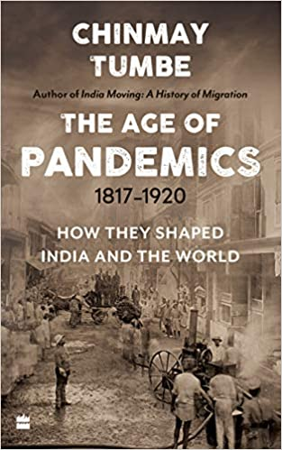

From lockdowns to lockups, viruses to vaccination, the movement of people to the movement of bowels, from rats to cats, and more, The Age of Pandemics chronicles the many facets of the cholera, plague and influenza pandemics, which claimed over 70 million lives between 1817 and 1920, with India being the epicentre in all these episodes.

The book argues that the period between the early nineteenth century to the early twentieth century - an age otherwise known for the worldwide spread of the industrial revolution, imperialism and globalization - was also the 'age of pandemics'. It documents the scale of devastation, the likely causes and consequences, and the resilience with which people faced those pandemics.

The book also provides the first comprehensive coverage of the world's greatest demographic disaster ever to descend upon a country in a short period of time - the influenza pandemic in India in 1918, which claimed more lives than all the battle casualties of World War I. And it shows the continuing relevance of learning from those times to tackle contemporary challenges, such as COVID-19.

7.

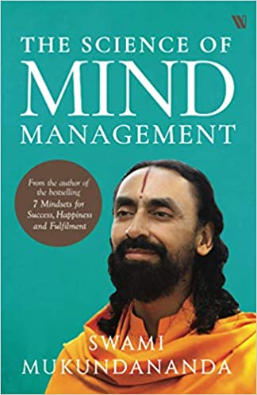

The quality of our mind determines the quality of the life we lead. It can be our greatest ally or our worst adversary. A mind that runs amok could steal our inner peace and undermine every productive endeavour. Yet, with proper knowledge, training and discipline, it is possible to unleash the mind’s infinite potential.

In *The Science of Mind Management,* Swami Mukundananda charts the four different aspects of the human mind and lays down a clear path towards mastering it. Through witty anecdotes, real-life accounts and stories from the Vedic scriptures, he gently guides readers on the road to winning their inner battle.

8.

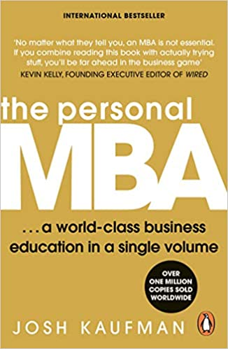

Getting a MBA degree has become difficult to justify not just because of the large price tag but also because of the growing impracticality. Even the elites like Harvard and Wharton offer outdated, assembly-line programs that teach you more about PowerPoint presentations than about how business really works.

For ten years, Josh Kaufman's The Personal MBA has served as an effective alternative introducing hundreds of thousands of readers to the most powerful business concepts of all time. He shares the essentials of entrepreneurship, marketing, sales, negotiation, operations, productivity, systems design, and much more, in one comprehensive volume.

The Personal MBA explains:

- The Iron Law of the Market: Why every business is limited by the size and quality of the market it attempts to serve-and how to find large, hungry markets  
- The 12 Forms of Value: Products and services are only two of the twelve ways you can create value for your customers  
- Option Fatigue: Why consumers are more likely to buy something when faced with three options rather than thirty - Entropy: Why focusing too heavily on creating new products and systems is a great way to go out of business

With The Personal MBA, you will avoid years of pointless group work, unhelpful financial models and daunting student loans. Instead, you will have gained the skills and tools necessary to take your place among today's business leaders.

9. 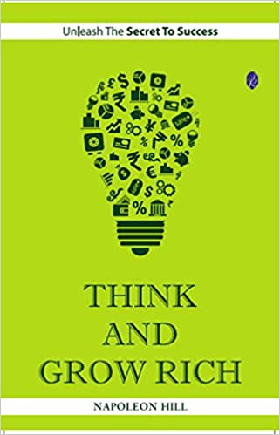

Think and Grow Rich has earned itself The reputation of being considered a textbook for actionable techniques that can help one get better at doing anything, not just by rich and wealthy, but also by people doing wonderful work in their respective fields. There are hundreds and thousands of successful people in the world who can vouch for the contents of this book. At the time of authors death, about 20 million copies had already been sold. Numerous revisions have been made in the book, from time to time, to make the book more readable and comprehensible to the readers. The book details out the most fundamental questions that once bothered the author, Napoleon Hill. The author once set out on a personal quest to find out what really made some people so successful. Why is it that some people manage to remain healthy, happy and financially independent, all at the same time? Why, after all, do some end up being called as lucky? The answers, no wonder, had to be no less than revelations. For more than a decade, the author interviewed some of the wealthiest and most successful people in the world. It was based on what author learnt in the process from all these people, when asked about how they achieved not just great riches but also personal wellbeing. The author formulated hundreds and thousands of answers, into concise principles which when acted upon, many claim, can help one achieve unprecedented success. The author has in many places narrated short stories and examples that help explain the concept at hand in an engaging manner. Think and Grow Rich teaches not just concepts but also methods. It is not a book that a reader can use for one time consumption. The book, even author recommends, has to be read one br>Chapter at a time and in sequence. Several readers and even some motivational speakers claim to have been reading this book over and over again, few pages at a time, for a long time now. Till date, it remains the number one self help book in the world, as far as sales are concerned! About author: an American journalist, lecturer and author, Napoleon Hill is one of the earliest producers of 'personal-success literature’. as an author of self-help books, Hill has always abided by and promoted principle of intense and burning passion being the sole key to achieve success. Hill has authored numerous books among which think and Grow Rich has been his most well-known works and had sold over 20 million copies back in the 1930s.

10. 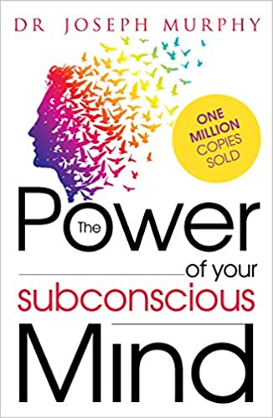

Did you know that your mind has a 'mind' of its own? Yes! Without even realizing, our mind is often governed by another entity which is called the sub-conscious mind.

This book can bring to your notice the innate power that the sub-conscious holds. We have some traits which seem like habits, but in reality these are those traits which are directly controlled by the sub-conscious mind, vis-à-vis your habits or your routine can be changed if you can control and direct your sub-conscious mind positively. To be able to control this 'mind power' and use it to improve the quality of your life is no walk in the park. This is where this book acts as a guide and allows you to decipher the depths of the sub-conscious.

In this book, 'The power of your subconscious mind', the author fuses his spiritual wisdom and scientific research to bring to light how the sub-conscious mind can be a major influence on our daily lives. Once you understand your subconscious mind, you can also control or get rid of the various phobias that you may have in turn opening a brand new world of positive energy.

**About the book**

The book is available in two types, the kindle edition as well as the paperback edition. The book contains 312 pages of wisdom and positive energy. The modern English language used is easy to understand.

**Book size:**

The book is sized at 19.6 x 13 x 2.5 cm which makes portable in nature.

**About the Author:**

Born in Ireland, Joseph Murphy was ordained in Devine Science and Religious Science. The way you see things will change completely after you finish reading this book.

You can bag this book from Amazon.in today by following a few easy steps.